Migrating databases from NON-ASM to ASM
- Login to DEV database and note down the path of all the datafiles, tempfiles and redo log files.
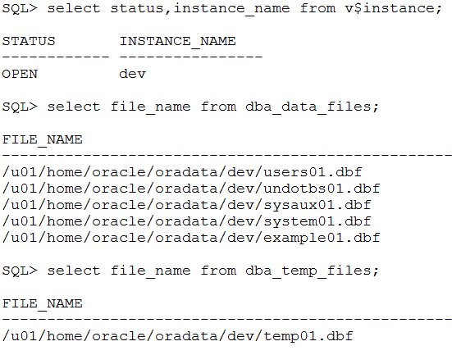
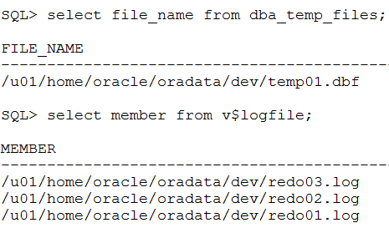
- Check the path of the controlfiles by querying the control_files parameter. Change this parameter to point to the ASM disk group DATA.
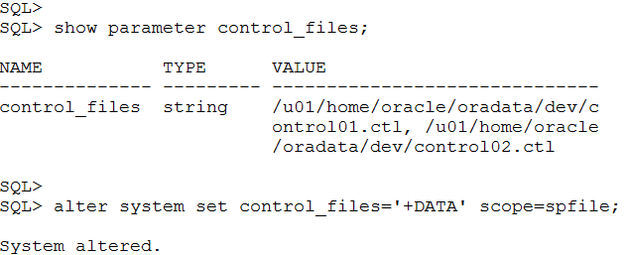

- Set the db_create_file_dest to point to the ASM disk group DATA. This says that all the data files needs to point to the ASM disk group DATA.
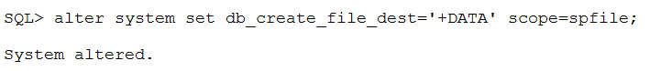

- Set the db_recovery_file_dest_size parameter with an appropriate size in order to store the archive logs. Also set the db_recovery_file_dest to point to the ASM disk group FRA. This sets the destination of the archive logs (The archive logs would get created and stored in the disk group FRA).
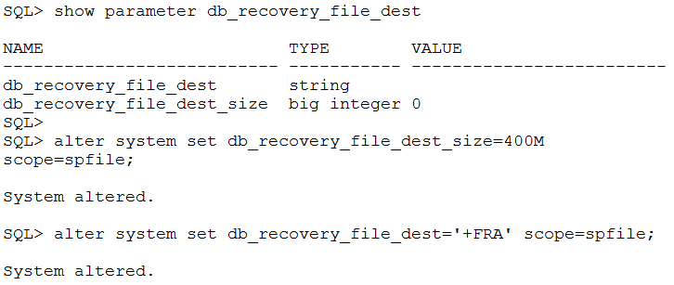

- Shutdown the database (DEV).
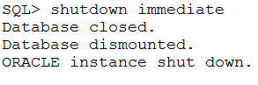
- Now startup the database in nomount stage.
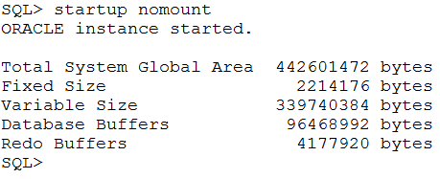
- Connect to RMAN and restore the controlfile from the file system to the disk group DATA.
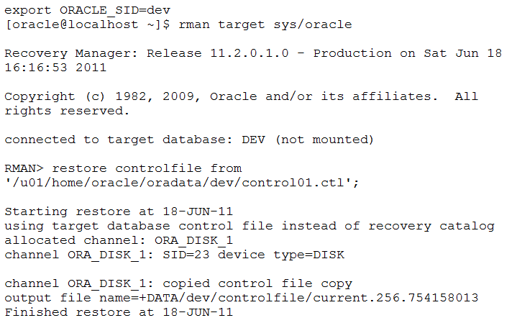
- Once when the control file is restored successfully, mount the database through the same RMAN session.
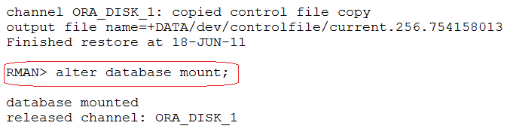
- Now take the backup copy of the database in the disk group DATA. This backup taken in the ASM disk group would be used as the datafiles of the database DEV.
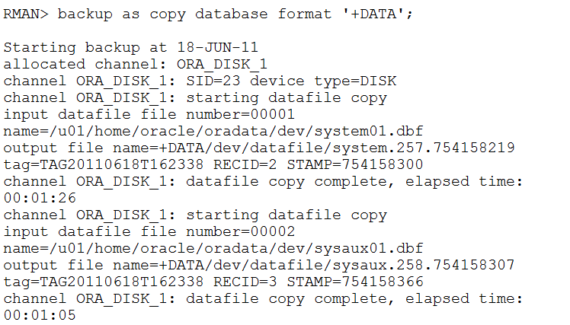
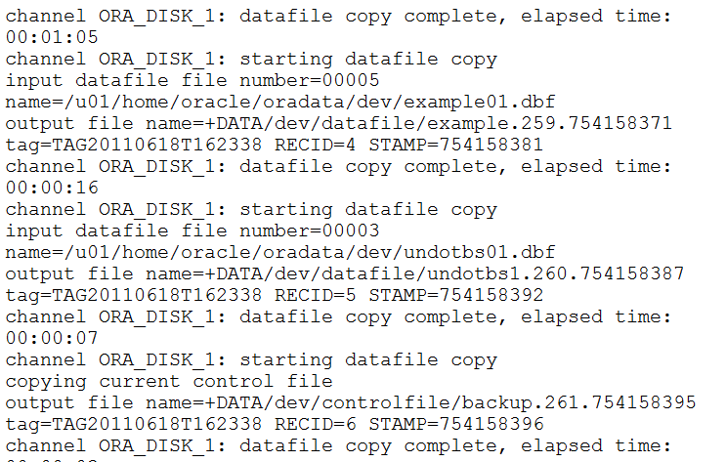
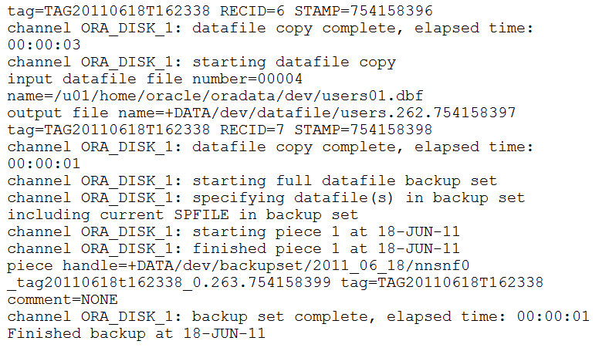
- Now we need to switch the non-ASM database to the ASM mode with the following command “RMAN>switch database to copy;”
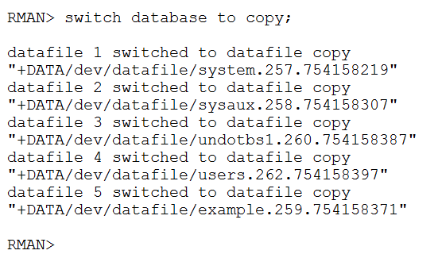
- Once the datafiles have been switched over from the file system to the ASM diskgroup successfully, open the database.
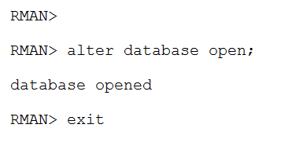
- Once when the database is opened without any errors, cross check whether all the datafiles have been moved to the disk group DATA or not.
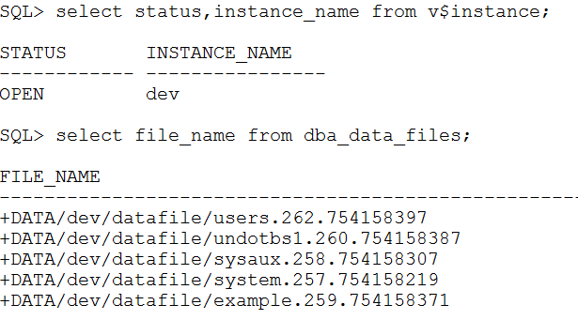
- Only the datafiles would be moved to the disk group DATA. We still have to move the Temp files and also the redo log files to the disk group DATA.
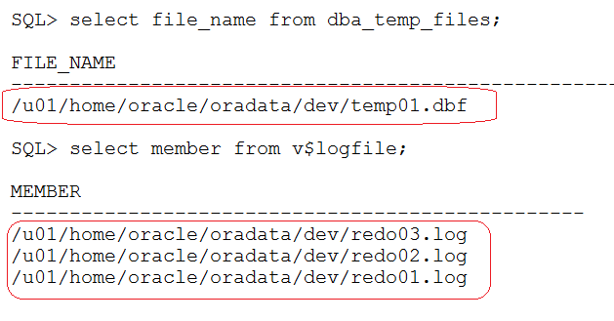
- In order to move the tempfiles, we need to drop the existing temp file which is existing in the file system and recreate it.
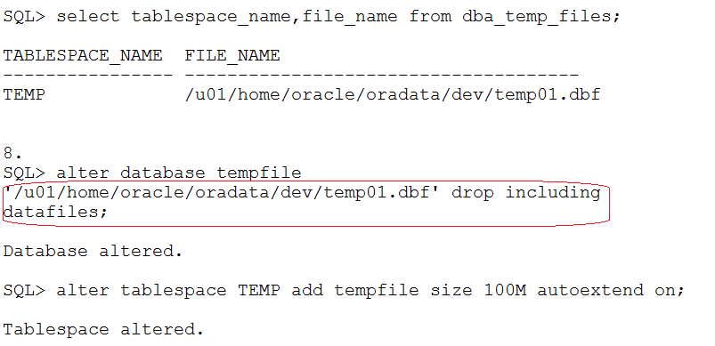
- Cross verify whether the tempfile created is in the disk group DATA or not.
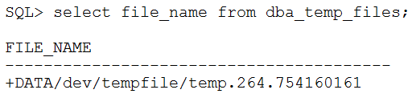
- Now we need to move the redo log files to the disk group. For this we first need to drop an inactive redo log group and then recreate it. In order to make a redo log group INACTIVE, perform switching of the log file by using “alter system switch logfile;” command.
In the below case, log group 2 and log group 3 are INACTIVE. Hence, we can drop and recreate the log groups 2 and 3.
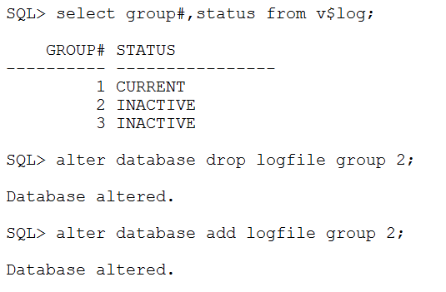
- Once the INACTIVE groups have been dropped and recreated, switch the logfile to make the next log group INACTIVE. Perform the same until all the INACTIVE log groups present in the file system have been dropped and moved to the ASM disk group.
When you recreate the redo log group after dropping it, a copy of the newly created log group would be placed in the both the disk groups (DATA and also in FRA).
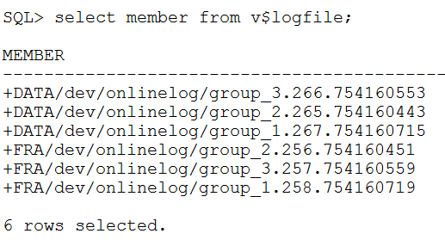
- Now the database DEV which had all its physical files on the file system, have now been moved to the ASM disk groups. Finally create a pfile for better usage.
Also the archive logs now would be getting created in the ASM disk group FRA because we have set the db_recovery_file_dest to point to the FRA disk group. Use the ASMCMD command to verify the same.
Set the Grid Home, oracle SID to ASM instance and use the ASMCMD command to view the contents of the disk groups and other related stuffs.

